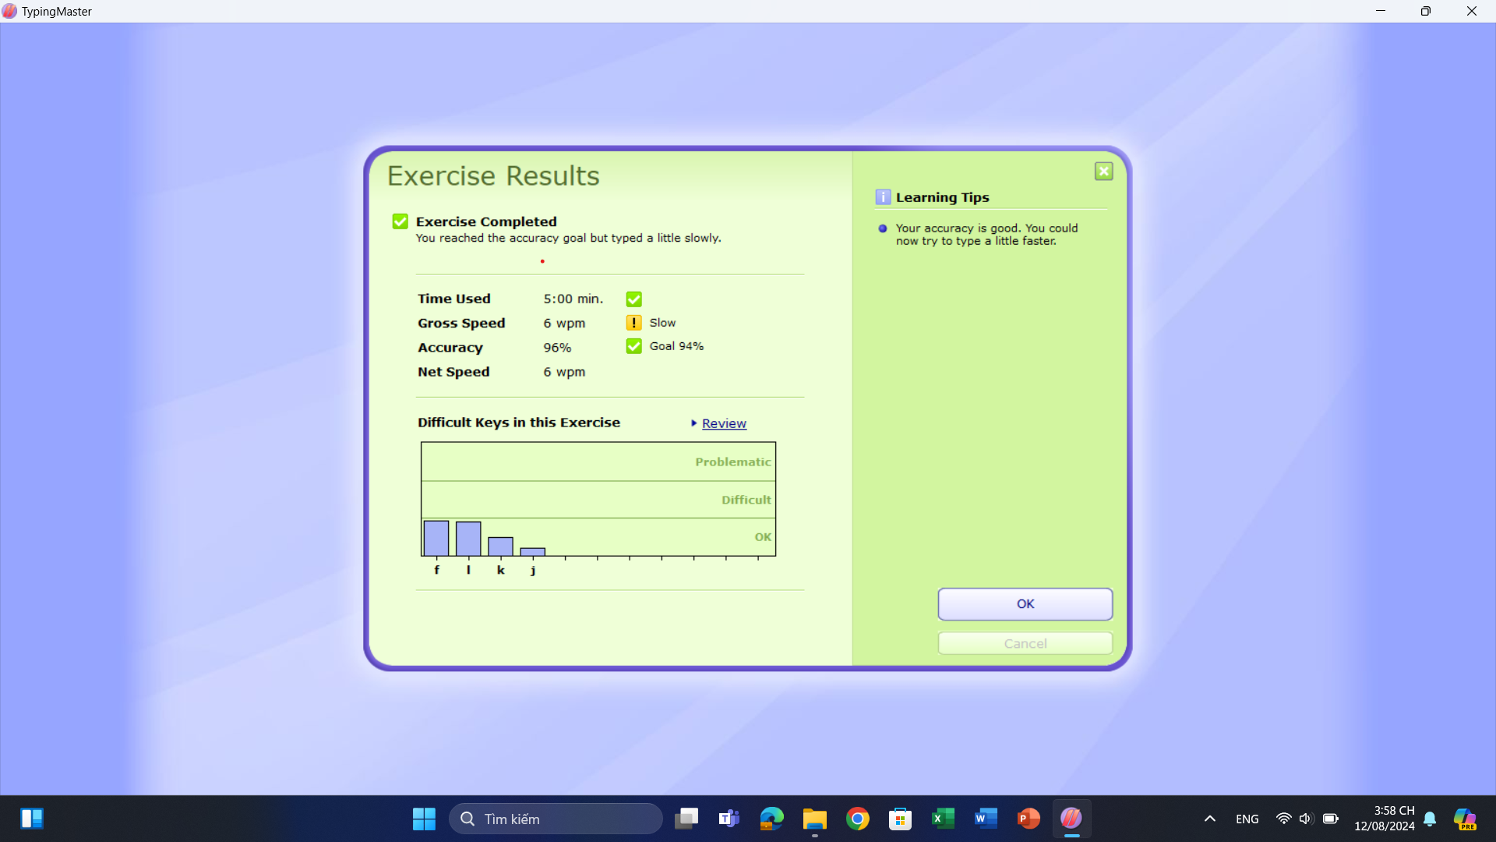

Hinh 1 Bai 1.4

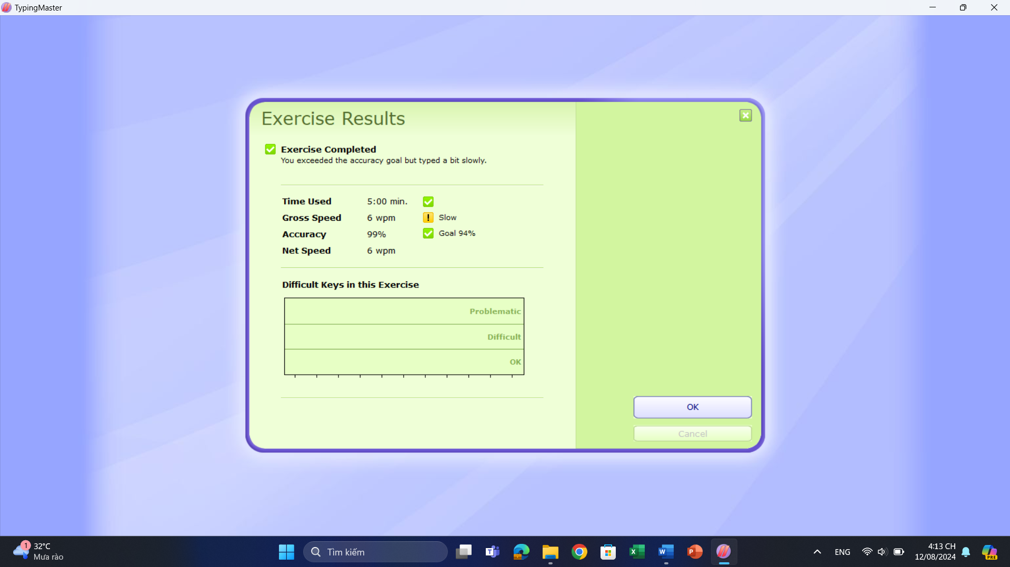

Hinh 2 bai 1.6

Hinh 3 Bai 1.7

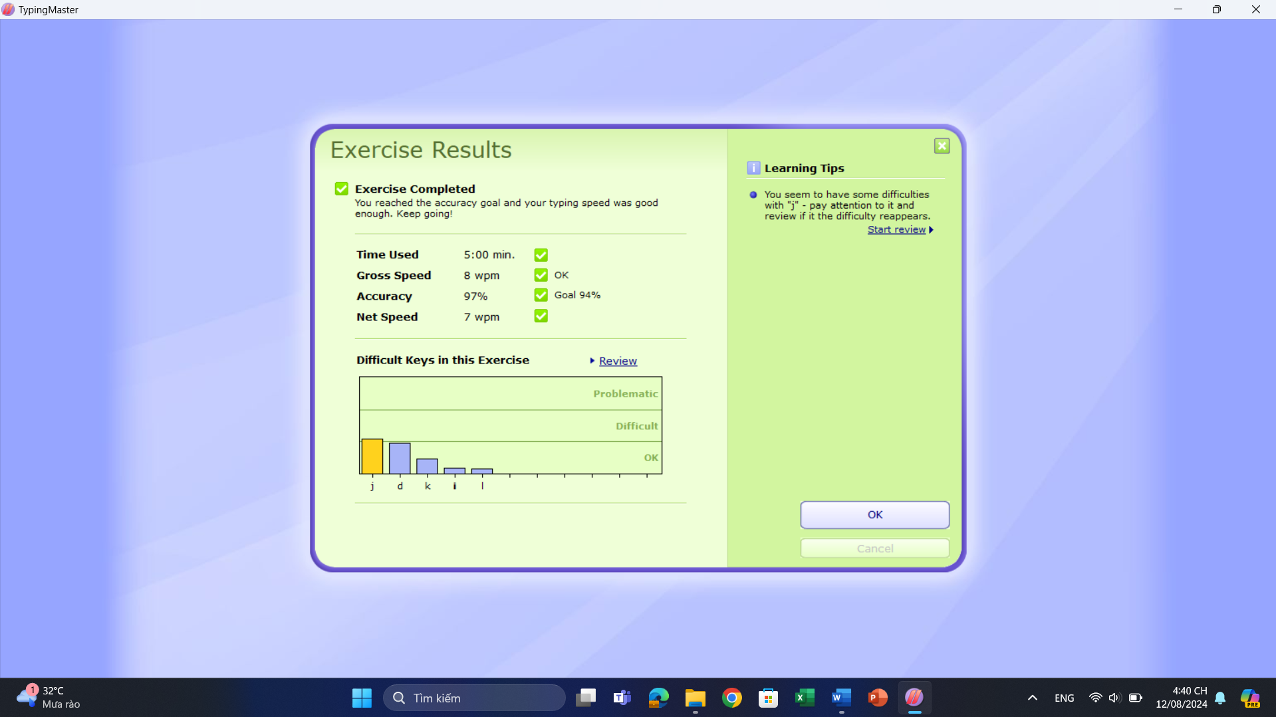

Hinh 4 Bai 2.3

Hinh 5 2.4

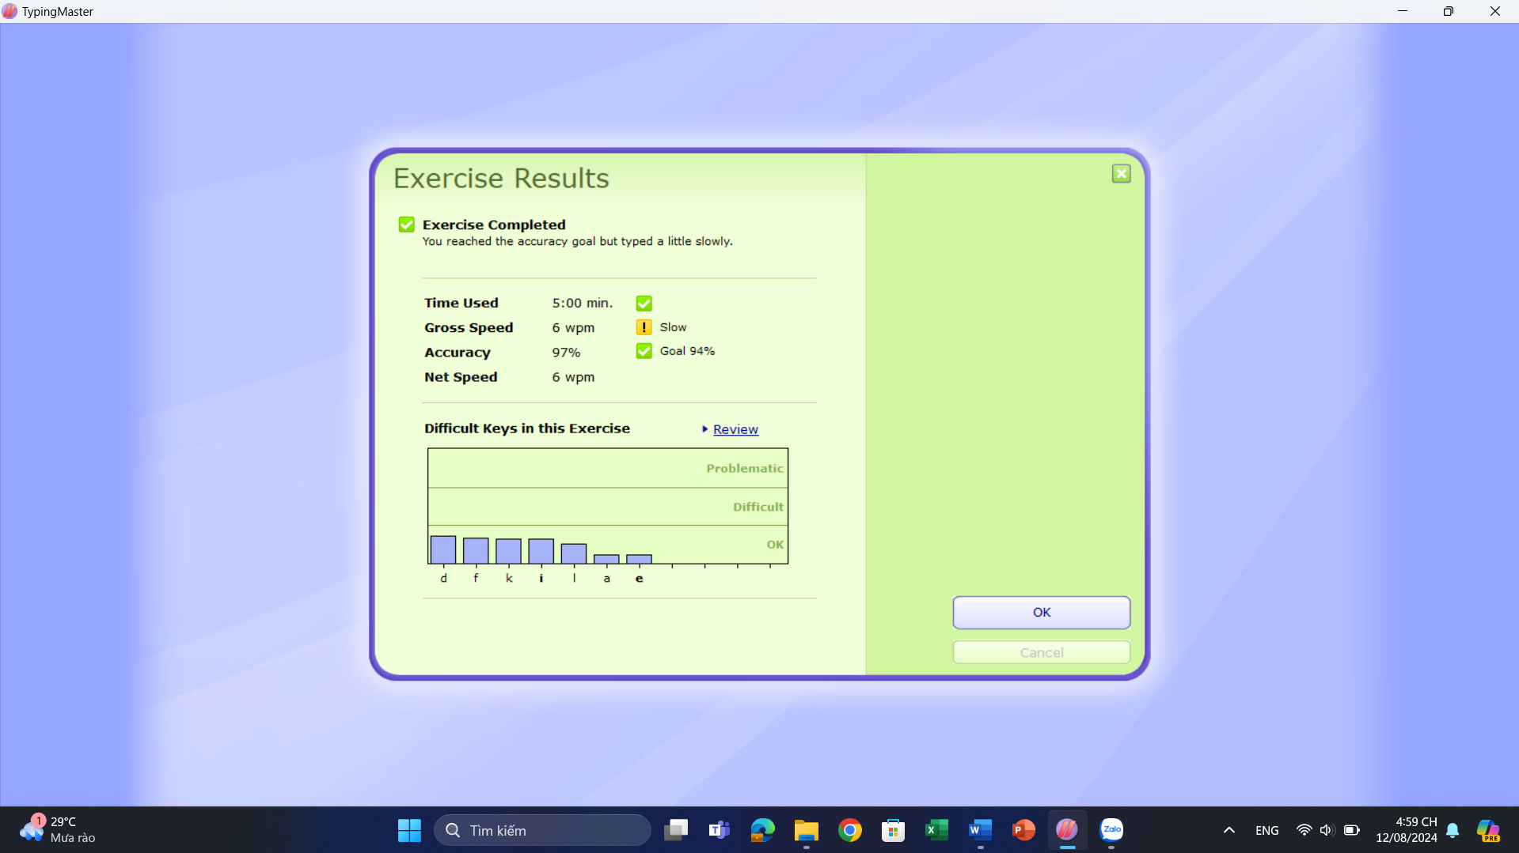

Hinh 6 Bai 2.6